6- Bit Even Parity Checker

EP=Σm{1,2,4,7,8,11,13,14,16,19,21,22,25,26,28,31,32,35,37,38,41,42,44,47,49,50,52,55,56,59,61,62,64,67,69,70,73,74,76,79,81,82,84,87,88,91,93,94,97,98,100,103,104,107,109,110,112,115,117,118,121,122,124,127}

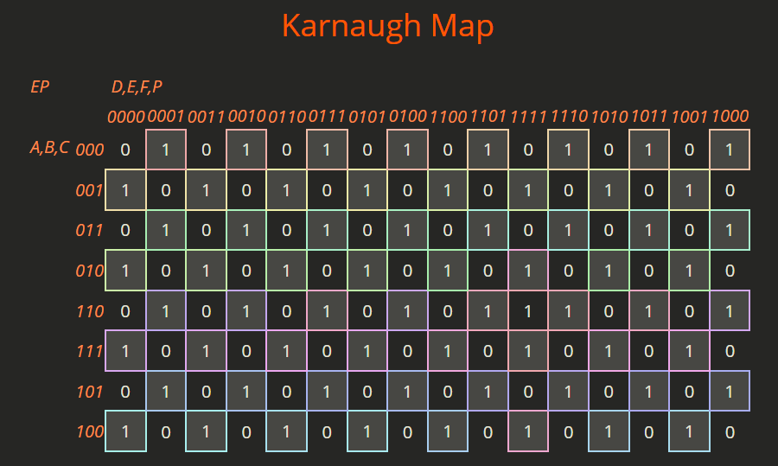

EP=( (A⊕ B) ⊕ (C⊕D) ) ⊕ ( (E ⊕ F) ⊕ P )

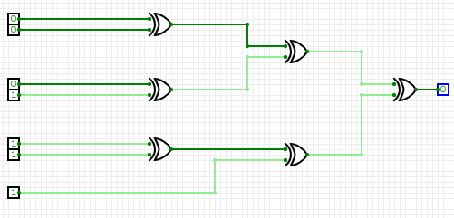

6- Bit Odd Parity Checker

O=Σ{0,3,5,6,9,10,12,15,17,18,20,23,24,27,29,30,33,34,36,39,40,43,45,46,48,51,53,54,57,58,60,63,65,66,68,71,72,75,77,78,80,83,85,86,89,90,92,95,96,99,101,102,105,106,108,111,113,114,116,119,120,123,125,126}
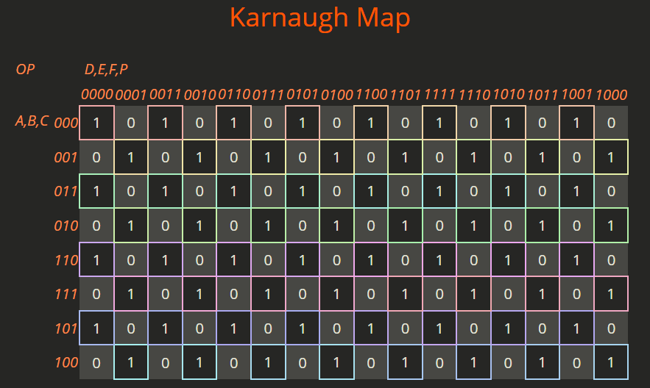

OP= $((A⊕ B) ⊕ (C⊕D) ) ⊙ ( (E ⊕ F) ⊕ P )$

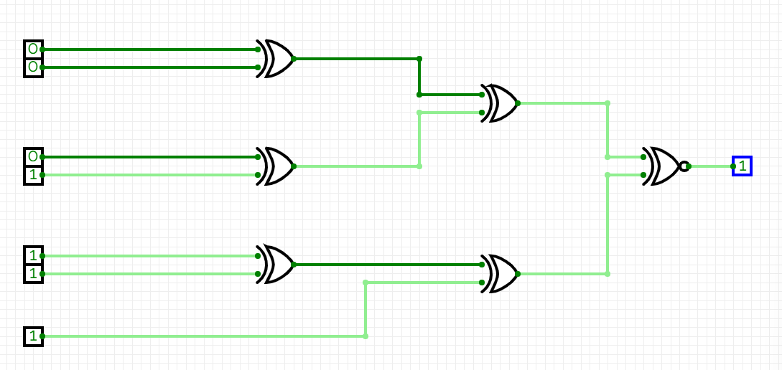

Links

Truth Table Google Sheet Link
6 BIT PARITY CHECKER TT.pdf

Circuit Verse Simulator Link
https://circuitverse.org/simulator/edit/even-and-odd-parity-checker-fe81a30b-3dcd-4668-b12a-e14819edc70c

K-Map Creator Link
https://charlie-coleman.com/experiments/kmap/

